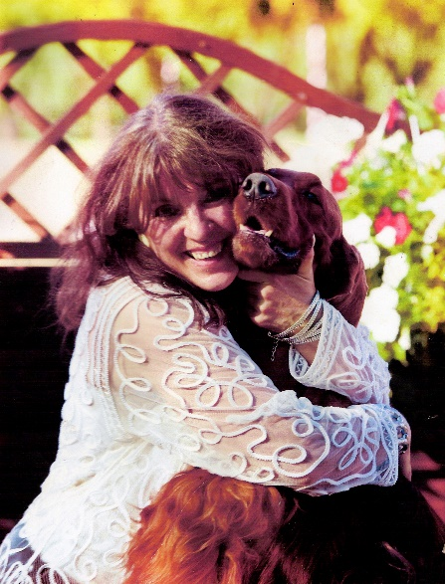
Jadwiga Konkiel
FCI JUDGE
GROUP VII, VIII, X
Phone: +48 606 350 324
E-mail: arisland@op.pl
jadwiga.konkiel@gmail.com
Web: www.arisland.pl

My lifelong adventure with cynology has begun in 1976, when I bought my first purebred irish setter – “ELDO z Hubertowych Włości”. Not long after he was joined by my first bitch – “Arisa-Aria z Wilanowskich Pól”, and it was her who became the namesake of my kennel – “Arisland”.
In the fourty years of activity, Arisland has been home to more than sixty litters of Irish Setters, with hundred and thirty of the offspring becoming Champions of Poland and many other countries, including Brazil, Portugal, Russia, Belarus, Ukraine, Czech Republic, Slovakia, Bulgaria, Macedonia, Hungary, Lithuania and Latvia, with thirty-five, and a few more still waiting for approval, becoming FCI Interchampions.
Over the years I’ve also imported several Irish Setters from the UK, USA, Sweden, Hungary, Netherlands and Belgium, while continuing to use foreign reproductors to refresh the bloodlines regardless of my imports.
While the Irish Setters are my great, lifelong love, my kennel has been the home for a few representatives of other breeds – Polish Lowland Sheepdogs, English Setters, Flat Coated Retrieves and Spinone Italiano, to be exact.
Among the achievements of my kennel are: World Winner (2x), Junior World Winner (2x), BIS Veteran World Winner (1x), BIS Veteran Europe Winner (1x), and the two titles for the Best Irish Setters Kennel awarded during WDS Helsinki (2014) and WDS Milano (2015), and the award for the Best Kennel during the European Dog Show in Brno. My Spinone Italiano have had great successes recently too, with a few more World Winner, Junior World Winner, European Winner, Junior European Winner, Club Winner and Interchampion titles added to the tally.
My judging experience dates back to the 90’s, where I’ve started judging Polish national dog shows, and after receiving my international judge permit, the club shows all around the Central & Eastern Europe. Over the years, I’ve also judged prestigious club shows in Sweden, Germany, Finland, and most recently – Australia and New Zealand.

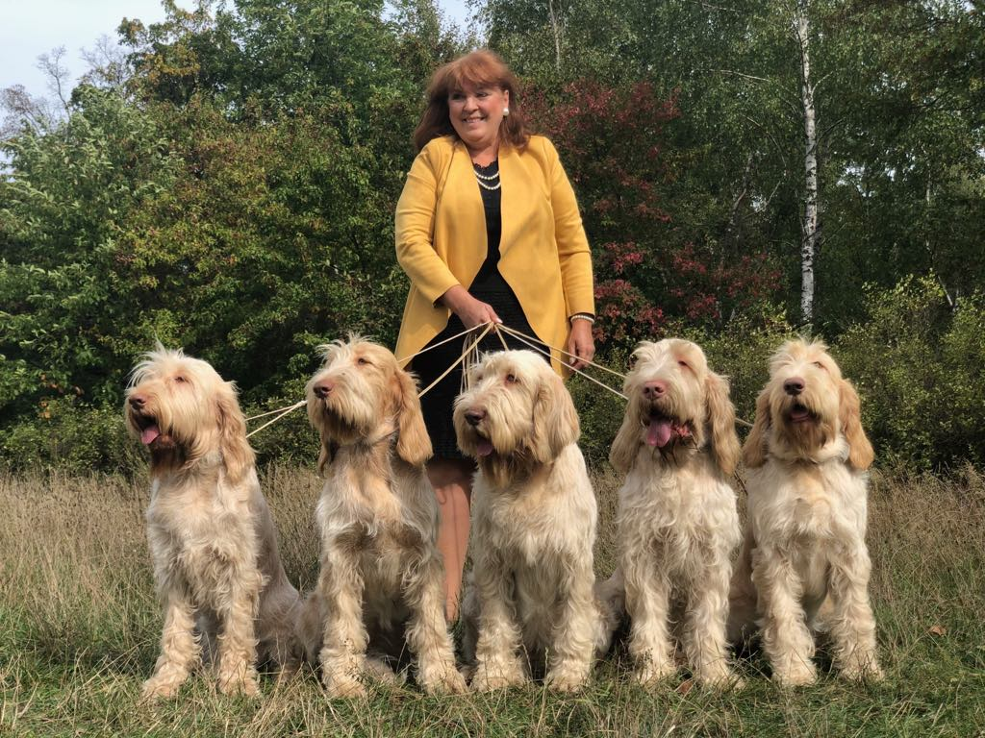

I’m permitted to judge all of the breeds from the VII, VIII and the X FCI groups. My hometown’s University of Natural Sciences and Humanities, which was my workplace since 1984, has been home to a couple of cynology-oriented seminars that I had the pleasure of conducting. The topis touched upon, included, among others:
“The highs and lows of breeding dogs”
“Cynology 101”
“How do you breed a champion?”
“How to handle a kennel and not go broke or crazy.”
“Old dog in a kennel.”
I’ve also written dozens of cynology-related articles, both for specialized press: “PIES”, “ASKO”, “Psy Myśliwskie”, and for popular national portals such as Onet.pl or “Z Pazurem”, with some of the most popular content being:
“Cynovirosis, the dog disease”
“I wish her the worst!”
“Grievous and small sins of a kennel”
“What’s this mahogany beauty all about?”
In the past, I’ve pioneered in Poland the practice of organized group trips to some of the world’s largest shows – e.g. Cruft’s, WDS, EDS, as a method of training and knowledge gathering exercise for the judges & assistants of the Polish Kennel Club. I’ve served as the VP of the Kennel Affairs Committee in the British Pointing Dogs Club of Poland. Currently, I’m the head of the Gundog section in the Warsaw’s office of the Polish Kennel Club.

